Install the Call Center Wizard app to your Bitrix24. While doing so give the app access to the following modules: CRM, Application embedding, Tasks, Users, Telephony and Drive.

**App setup**

*Sales scripts*

Here you can add as many sales scripts as you want but you can activate only one of them.

To add a new script click "Add script" button. Enter name and description and press "Save". You can find the script details by clicking on its name in the list.

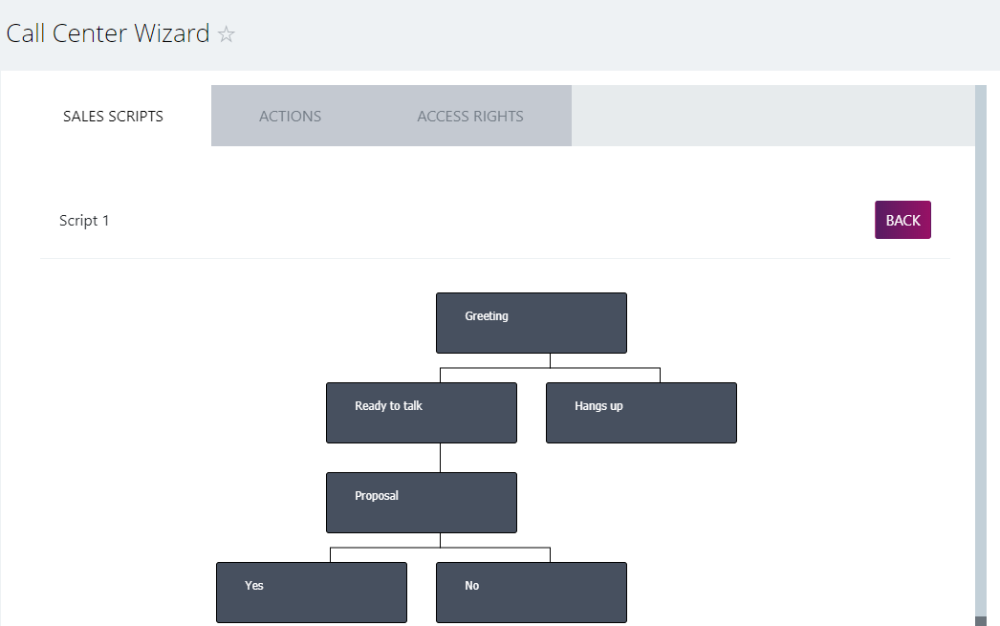

Click on the block to edit it. Except for the first "Greeting" block where both fields refer to the operator's words, "Answer" field is for the client's reply (for example, yes or no) and "Answer description" is for what the operator shall say in response to the client's words.

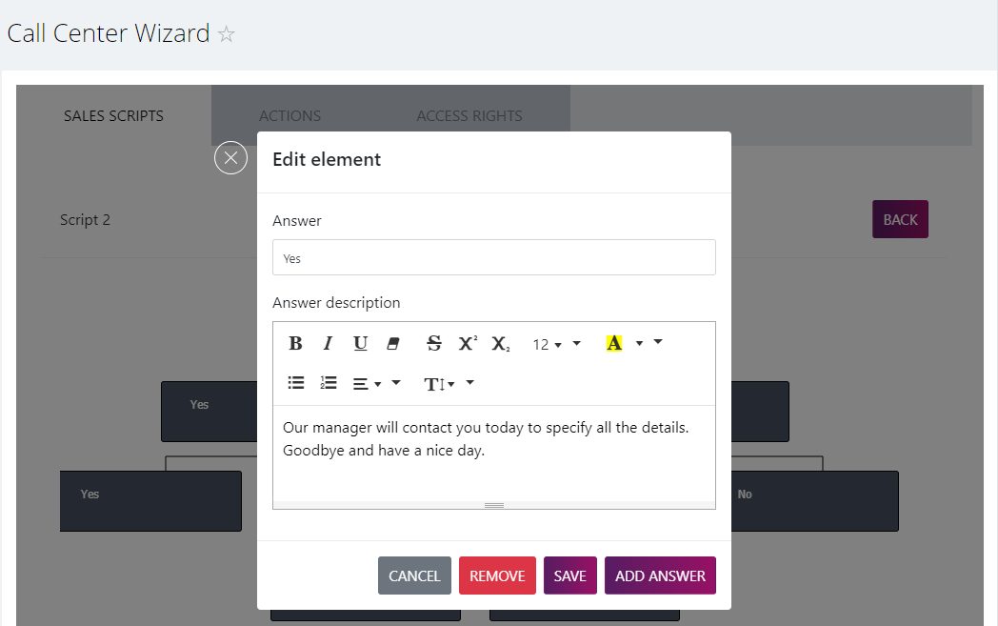

Save — save name and description of this particular block.

Remove — delete the block that’s being edited (NB: you cannot remove the Greeting block from the script).

Add answer — add the block for your client’s reply beneath the current block. As the result you will see a new block connected to the previous one where you can add your client’s and operator’s reply and so forth.

All changes in the particular script are saved automatically. To see the list with all scripts click "Back".

*Actions*

Here you can set the buttons that operators see at the end of the conversation with the client and that launch one or several actions (call back, set a task, etc.).

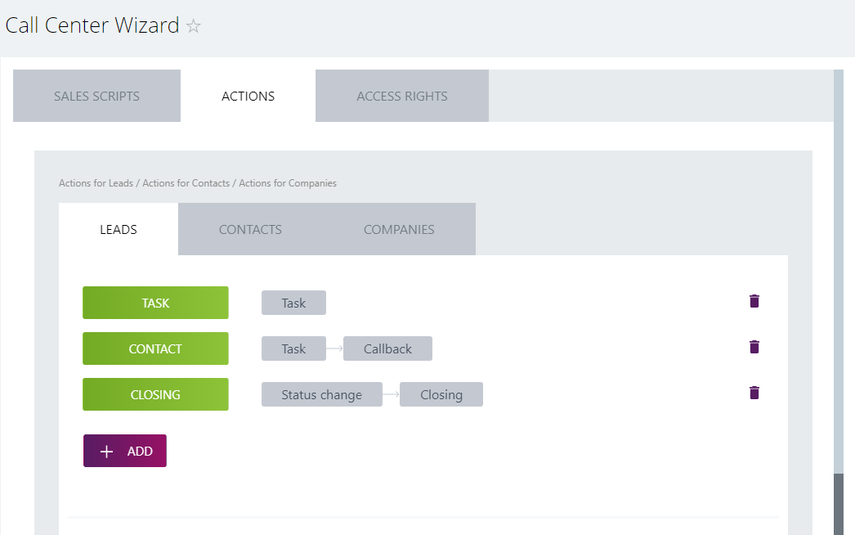

Action buttons are set separately for all entities (Leads, Contacts and Companies).

Click “Add”, set the name and then choose one or several actions. Click "Save".

Then click on the action and set required parameters (for example, date of the prospect meeting or call back, name and description for the task, etc.).

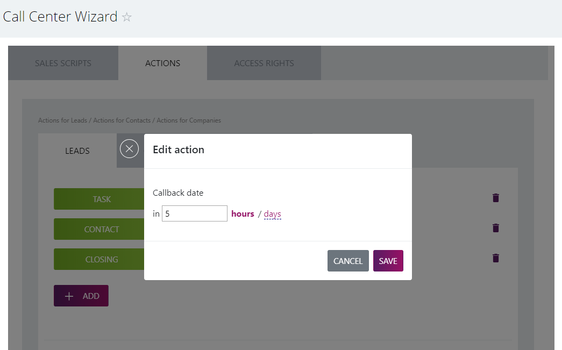

*Access rights*

Here you can see two conceptual blocks: roles list and users list.

First you should create a new role. Click "Add role" and insert the name for it.

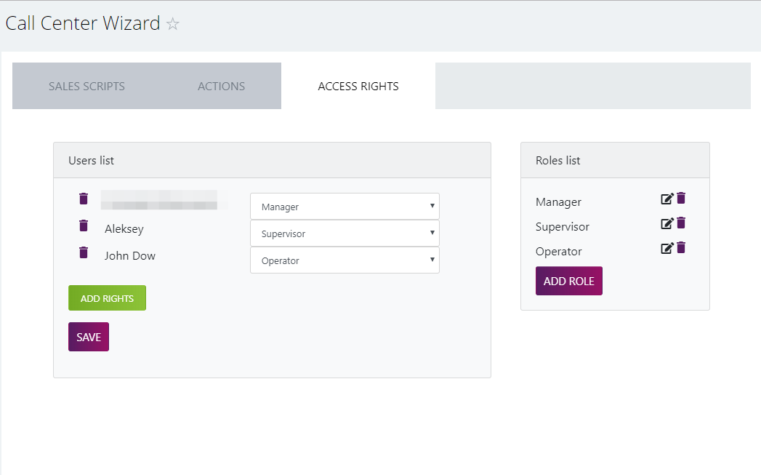

In Settings bar check Show "Sales script" box if you want to show it in the call card.

In actions blocks for CRM entities (Lead, Contact and Company) choose the buttons that are to be shown in the call card.

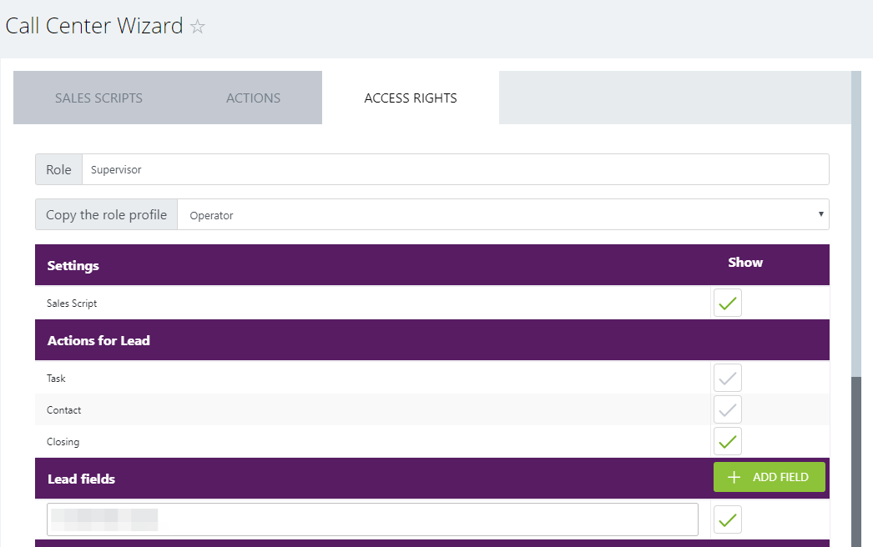

In the Fields blocks for CRM entities choose the fields that are to be shown in the client’s info space of the call card. All new fields are automatically added with ID default setting. Click on it and choose any needed field from the list. Lead’s name, First name and Last name and Company’s name are obligatory fields and they cannot be removed.

"Copy the role profile" bar lets you choose any previously created role, copy its parameters and insert some minor changes to save your time from doing it from scratch.

When you’re done with the roles parameters press "Save" and the system will redirect you to the main page of the "Access Rights" tab where you can edit or delete any created role.

In the "Users list" you should choose employees who work with the call cards. Click "Add rights" and choose relevant user. Then set his role to the right and press "Save".

